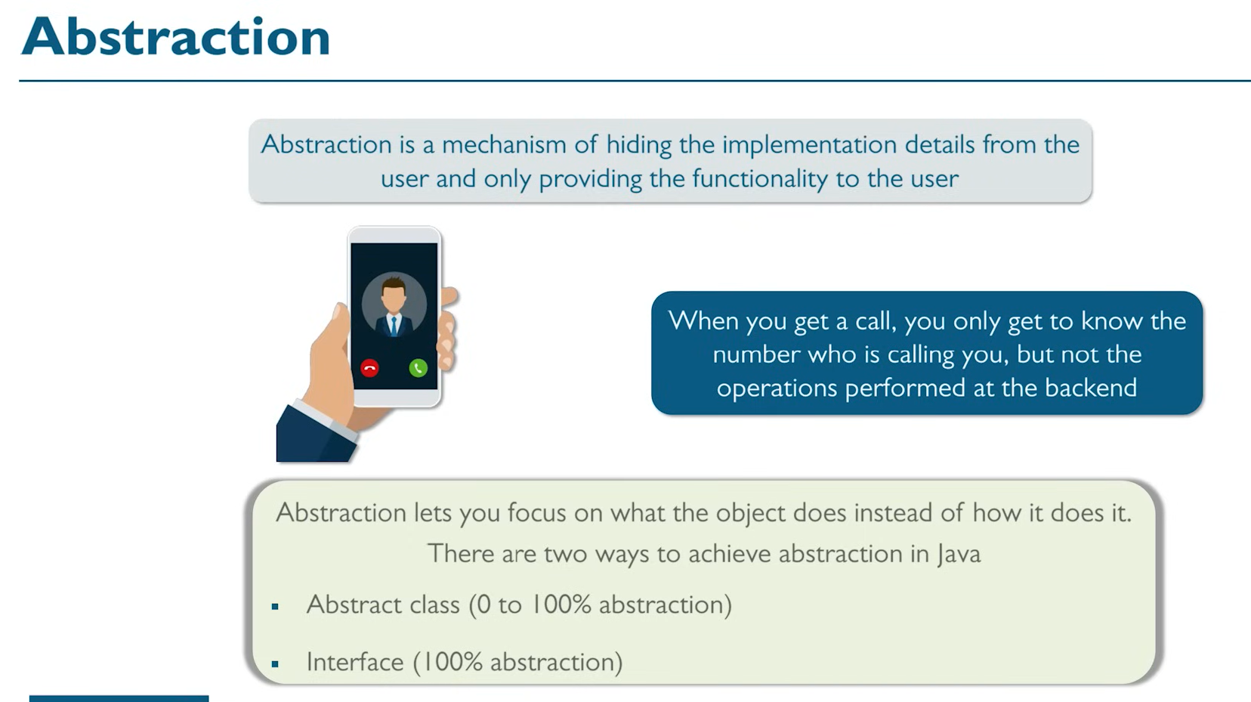

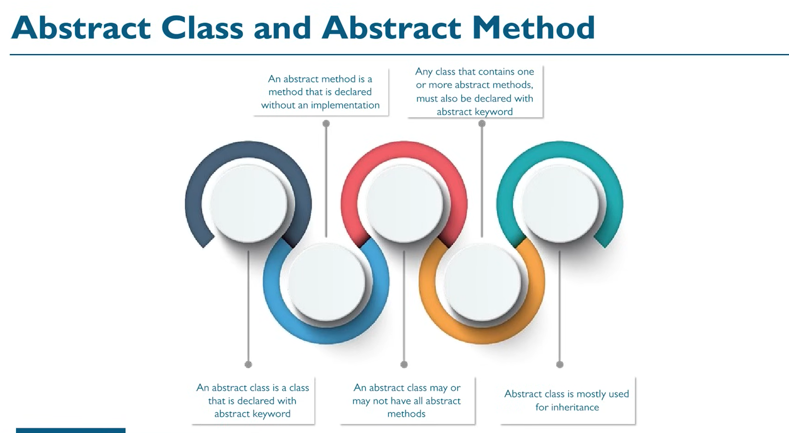

# Abstract Keyword and its usage:

In the below example, there is a class called Car, and another class which extends Car called WagonR. While writing methods for Car class, the developer realizes that drive() method cannot have anything to be inherited and is completely defined by the child class. In such cases those methods can be **declared** as ABSTRACT methods.

Abstract methods can only be inside abstract class. That means we **cannot create objects of abstract classes directly. We need to instantiate objects that extend the abstract class. Also its mandatory to define all the abstract methods.**

We could have cases where a class which extends the parent abstract class may also not be able to define an abstract method. In that case (like " abstract class WagnoR extends Car” it will also have to be defined as abstract.

abstract class Car

{

// public void drive()

// {

//

// }

public abstract void drive();

public abstract void fly();

public void playMusic()

{

System.out.println("play music");

}

}

abstract class WagnoR extends Car

{

// public void fly()

// {

// System.out.println("Flying...");

// }

public void drive()

{

System.out.println("Driving...");

}

}

class UpdateWagnoR extends WagnoR //concrete class

{

public void fly()

{

System.out.println("flying...");

}

}

public class Demo{

public static void main(String[] args) {

// Car obj=new Car();

// Car obj=new WagnoR();

Car obj=new UpdateWagnoR();

obj.drive();

obj.playMusic();

}

}

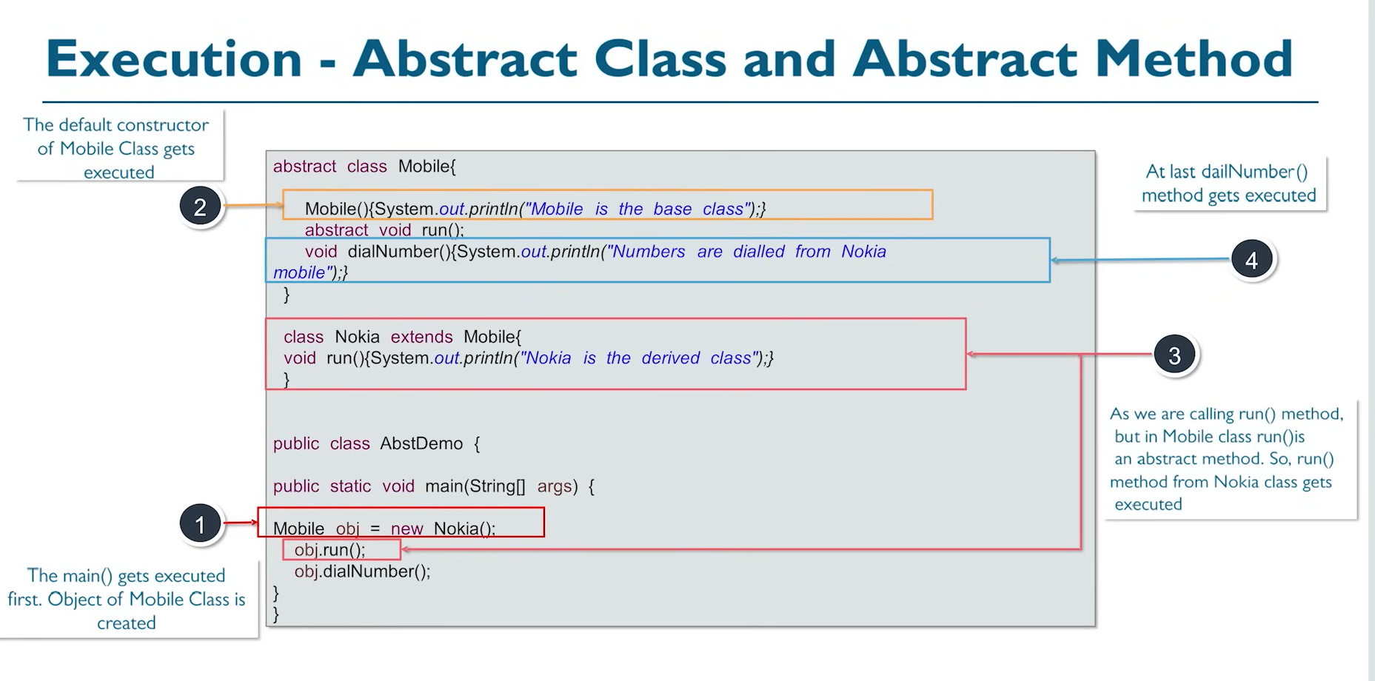

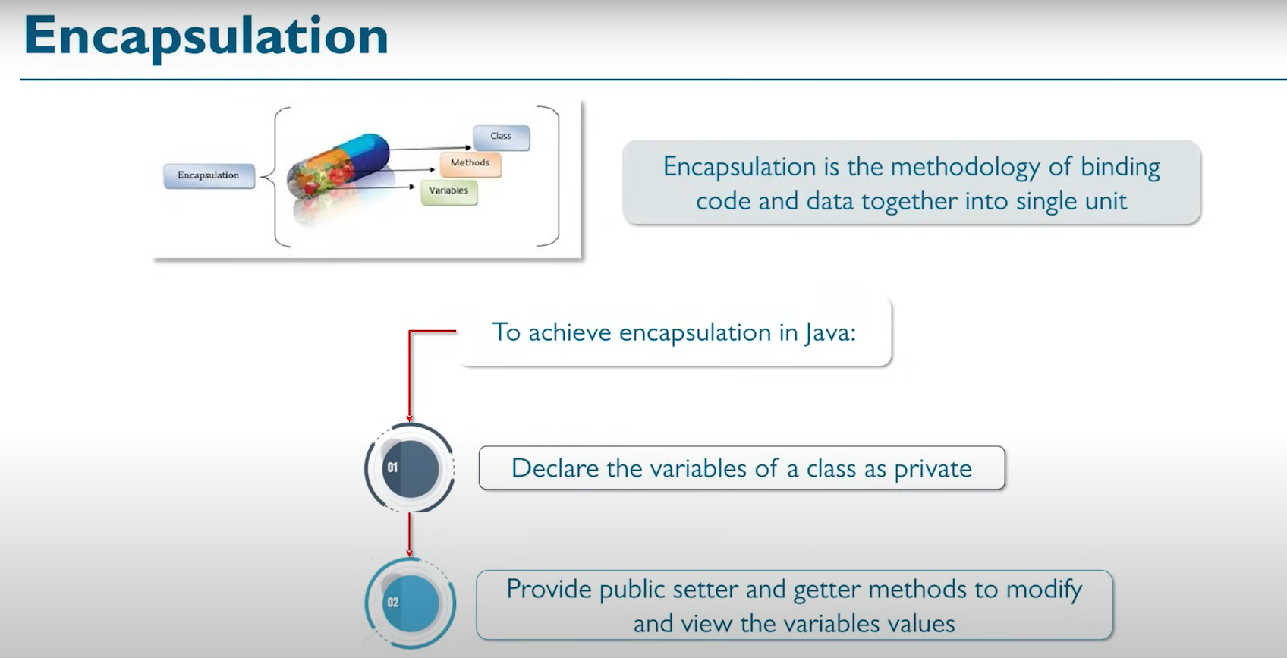

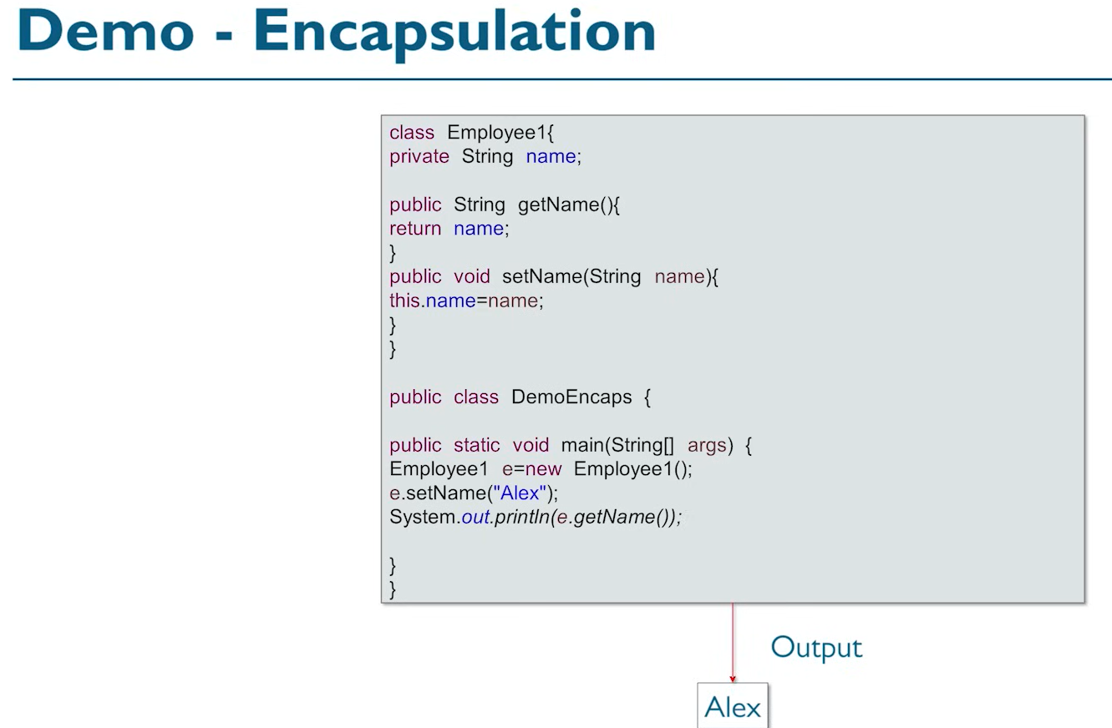

Encapsulation is basically how we create getter and setter methods so that we do not want to expose everything to everyone. Getters are more used than setter methods.

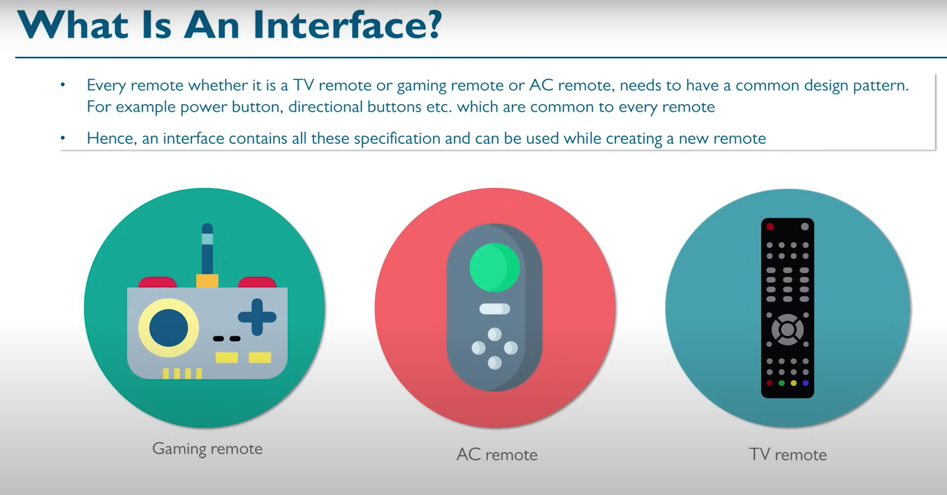

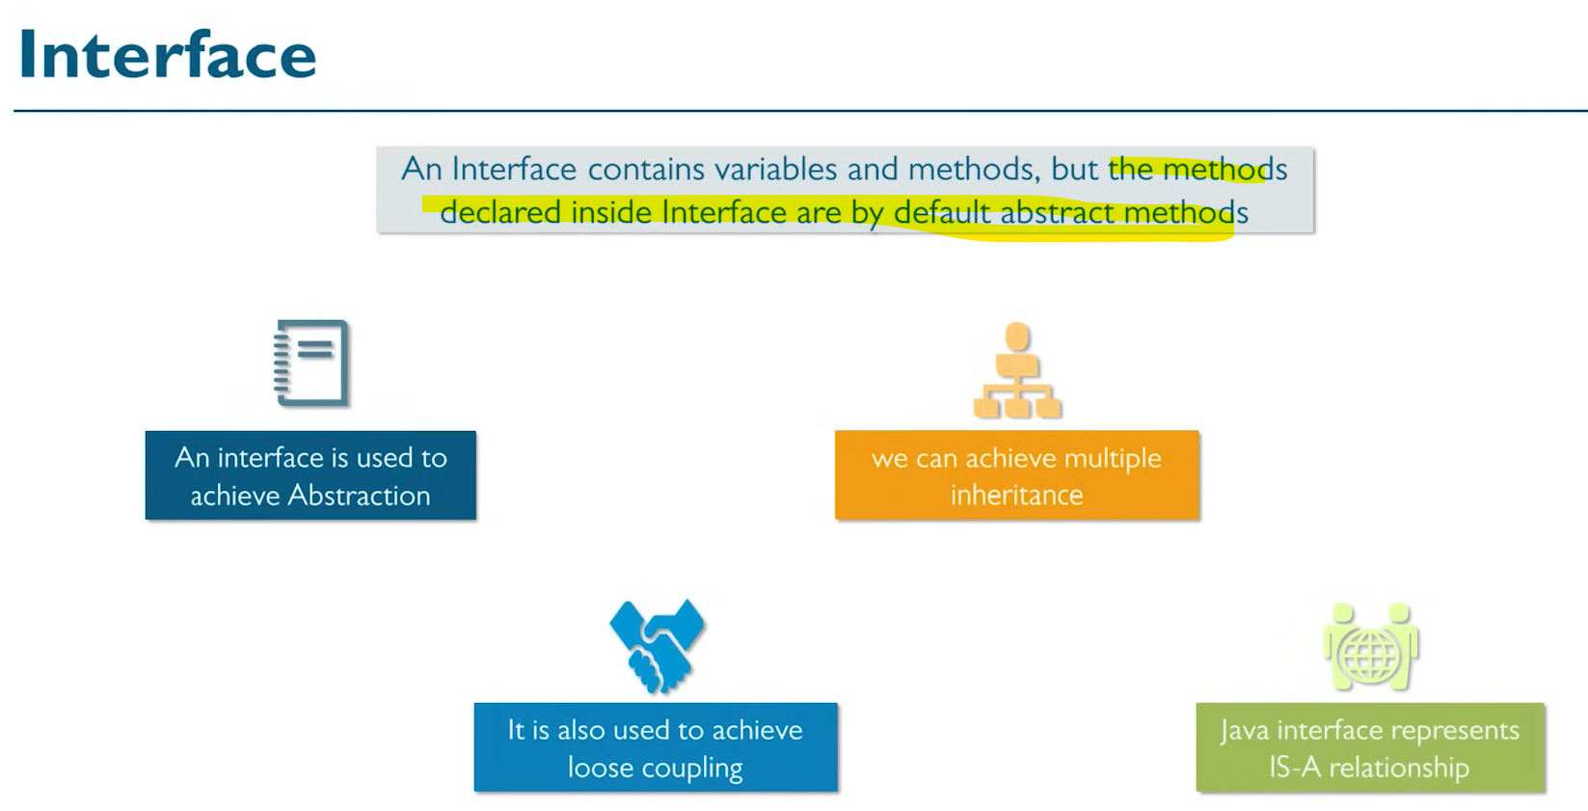

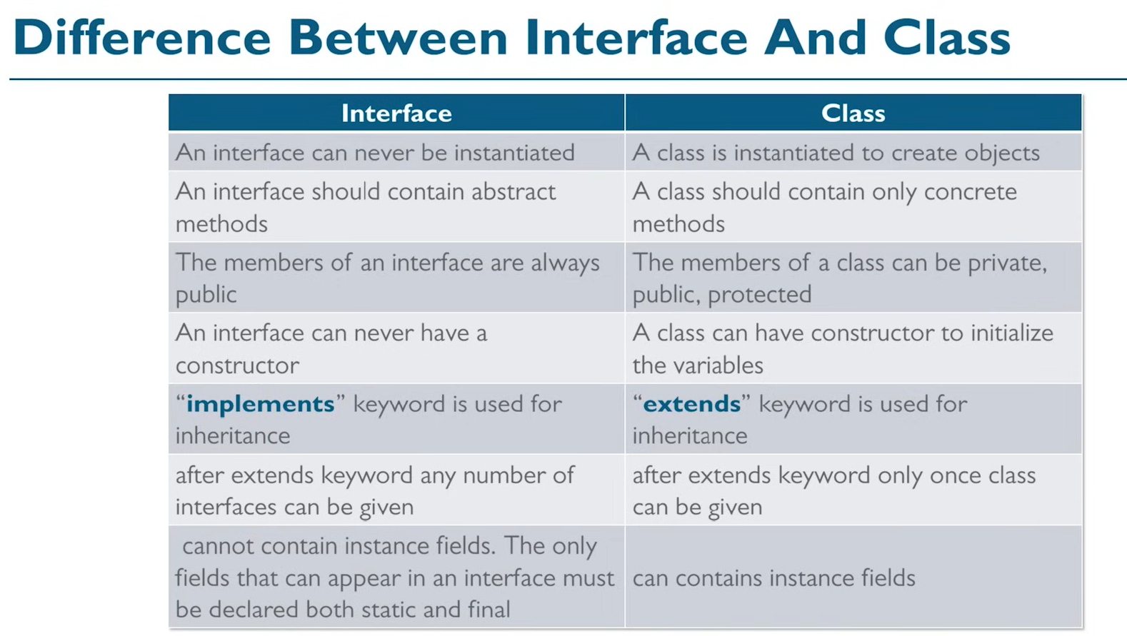

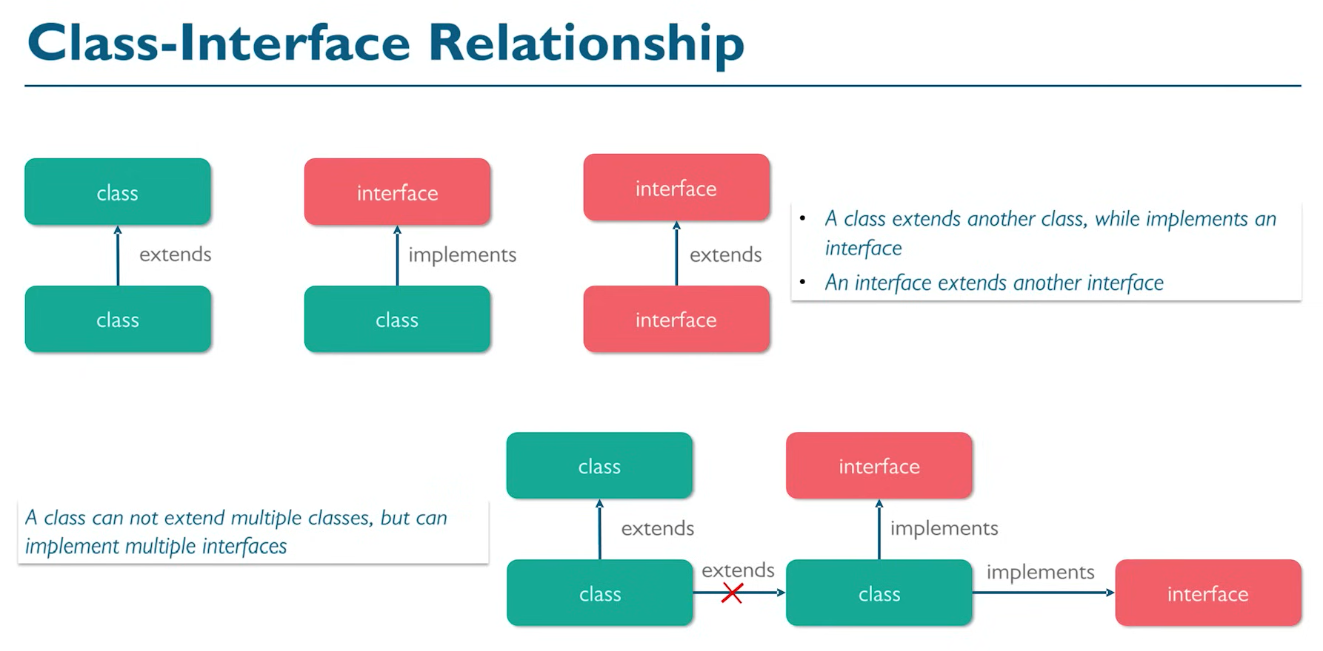

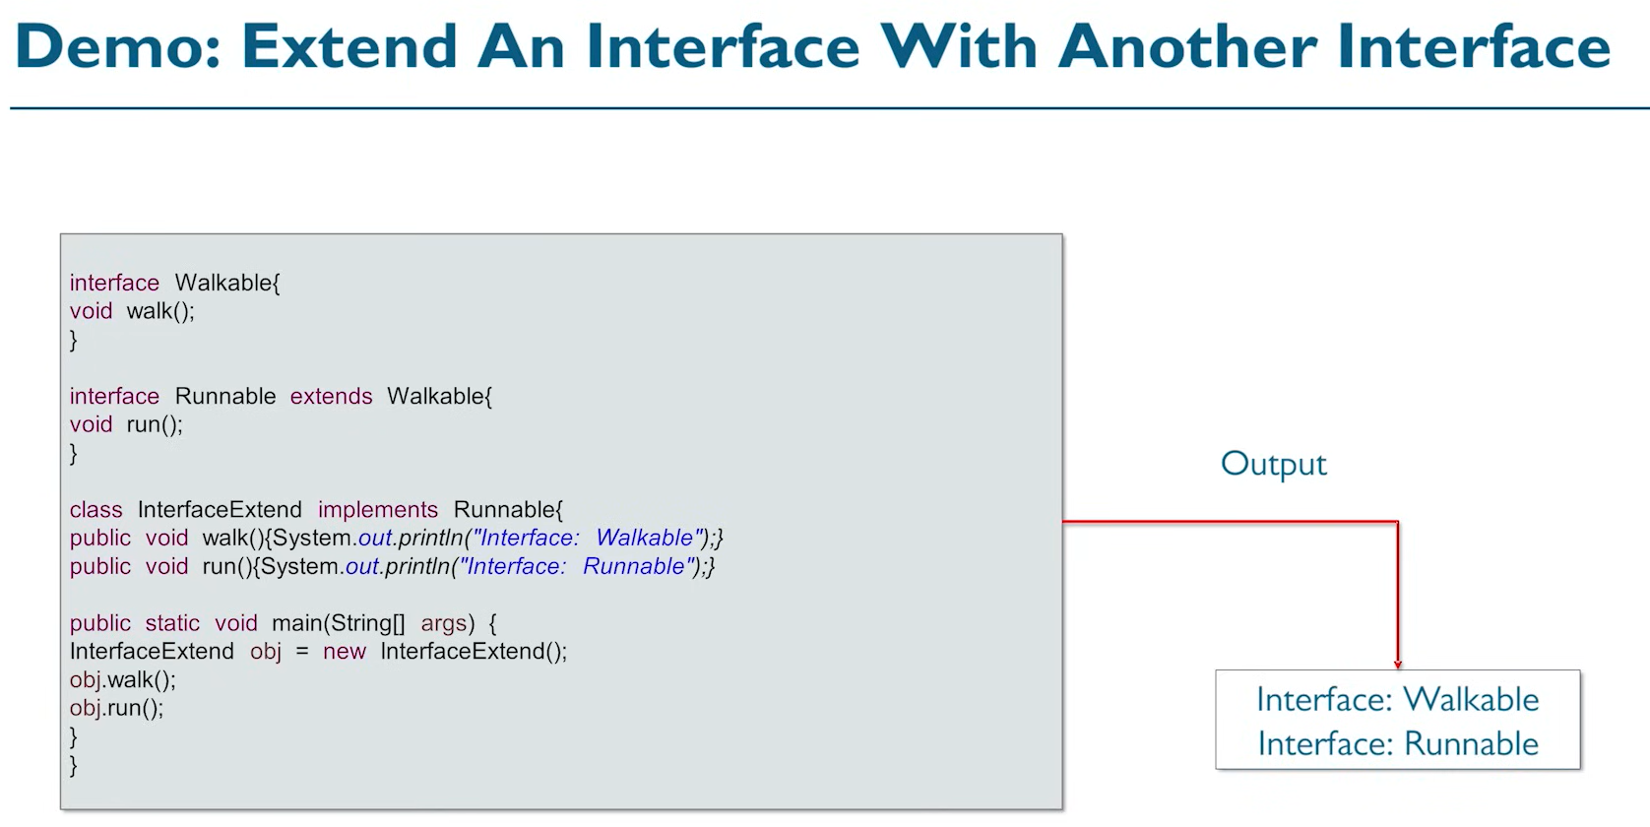

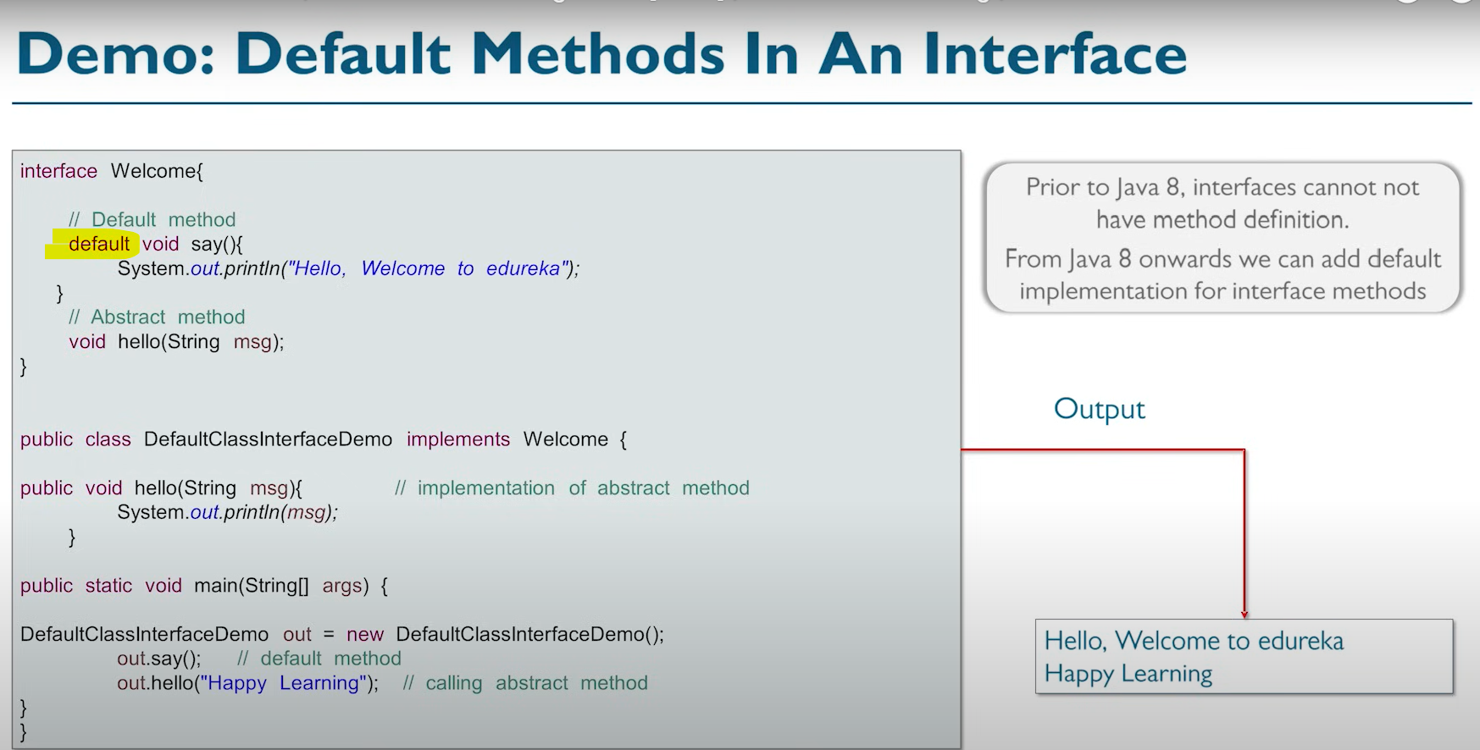

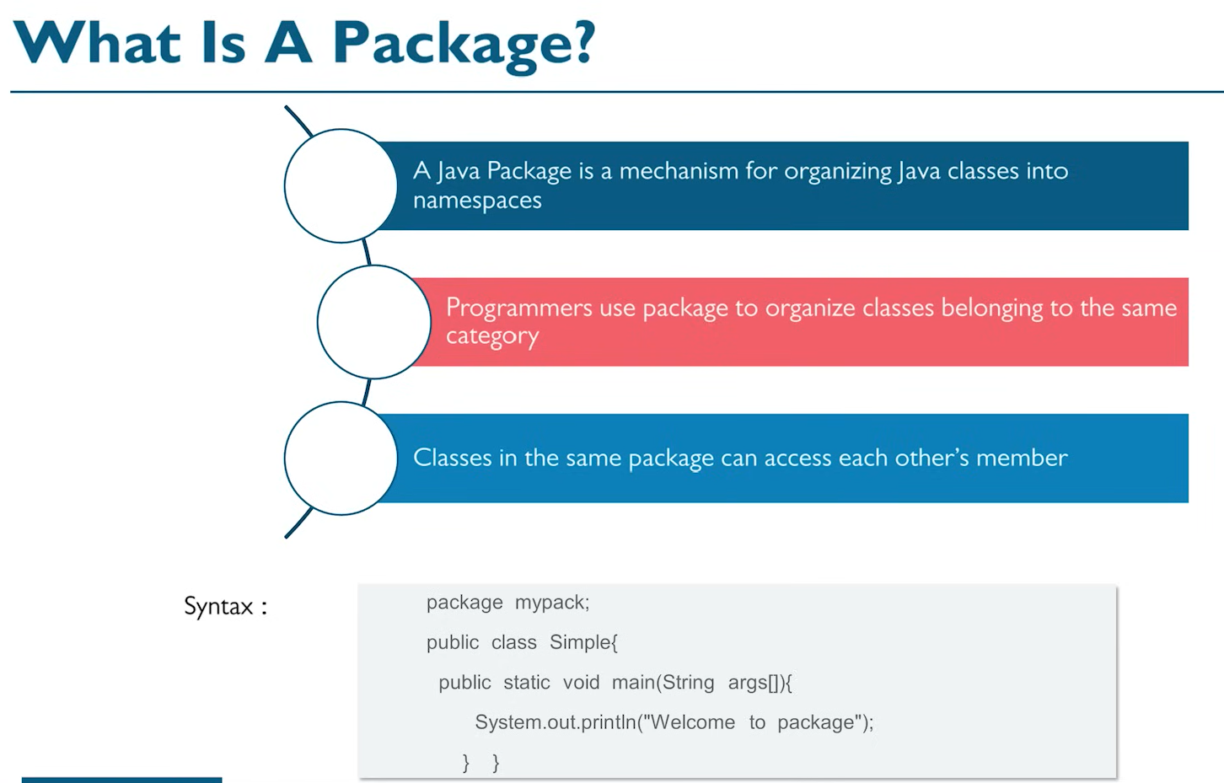

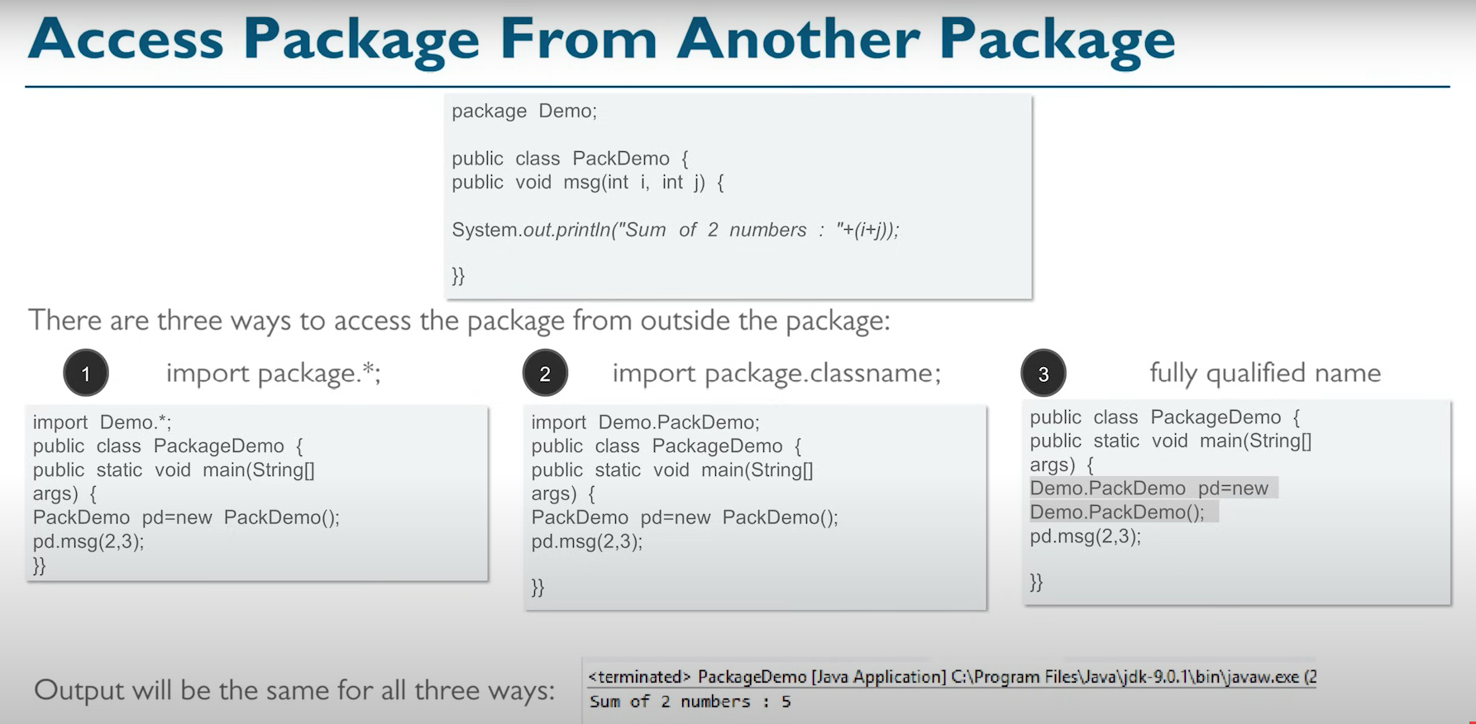

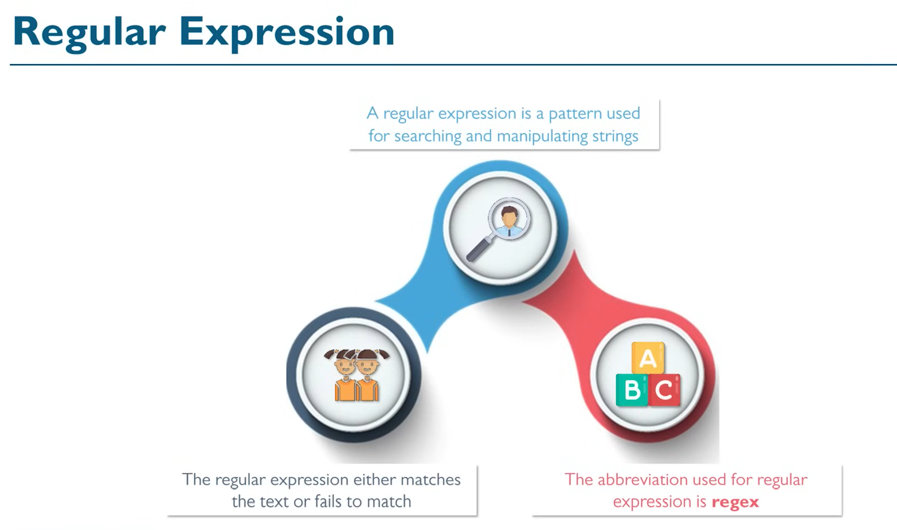

E.g. this can be used to validate email Id format.

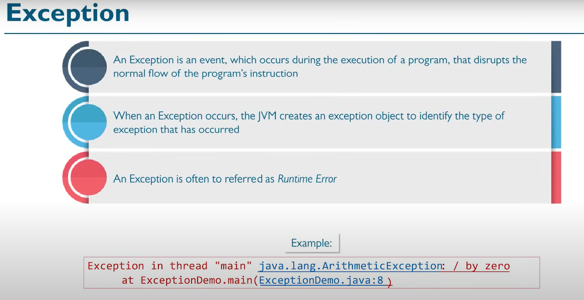

Errors are of 3 types:

1. Compile time error – Easy to solve as it shows during compilation. Syntactical errors.. etc
2. Runtime error – Execution just stops. No error during compilation. E.g. we reference a file and the file is no more. **These are called exceptions**
3. Logical Error – No compile issues. This is where we need testing

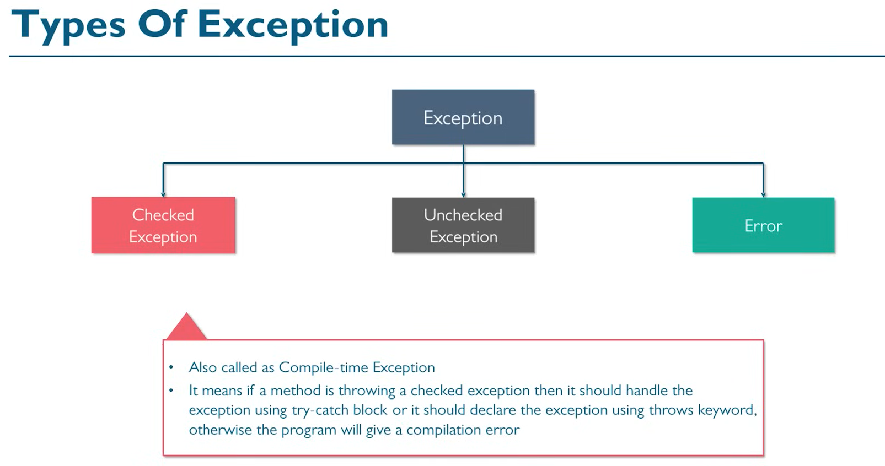

Unchecked are exceptions are at Run Time. E.g. divide by 0. For Error:

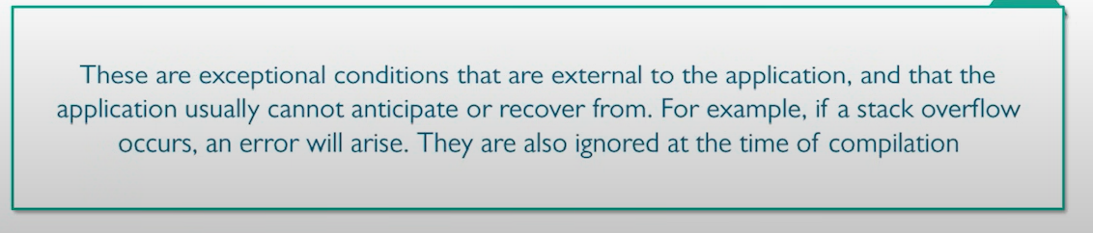

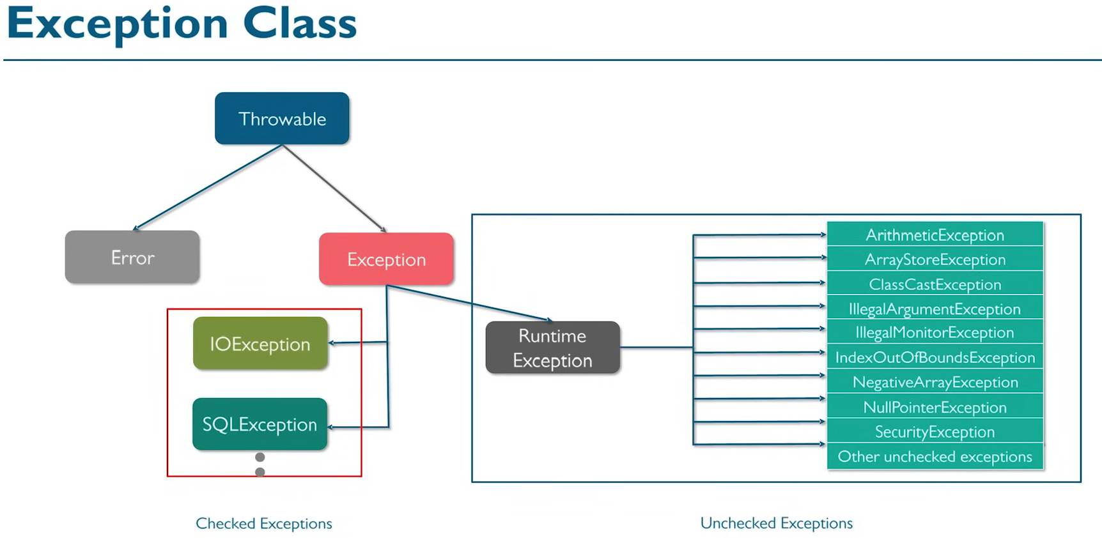

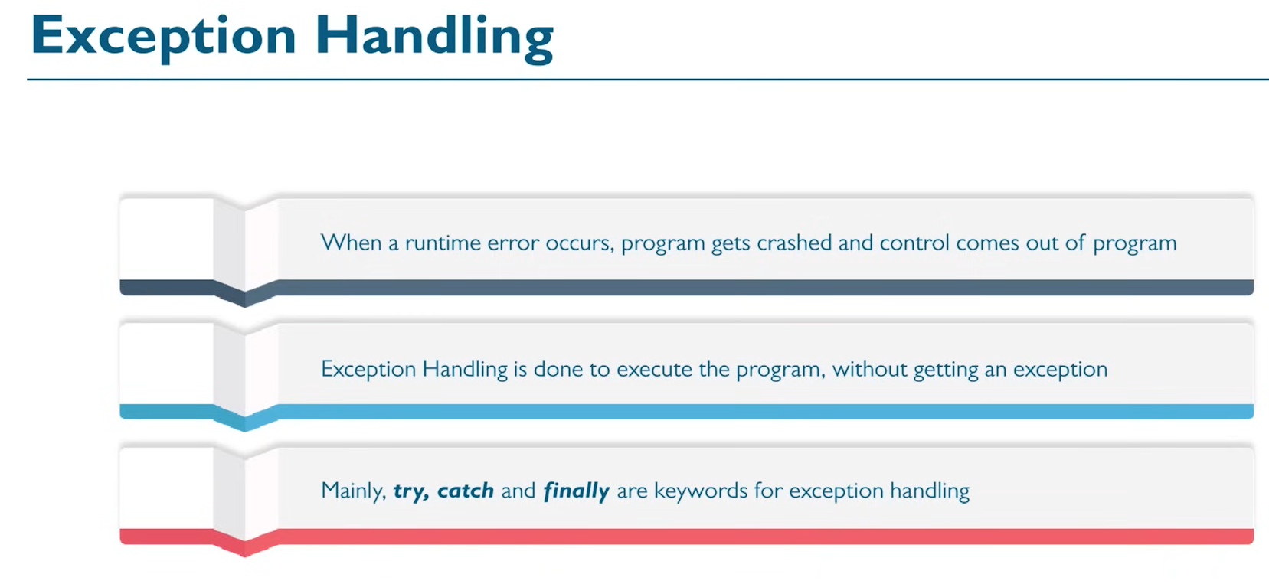

It is better to put **critical statements**, i.e the statements that may cause an error inside the try block instead of having everything.

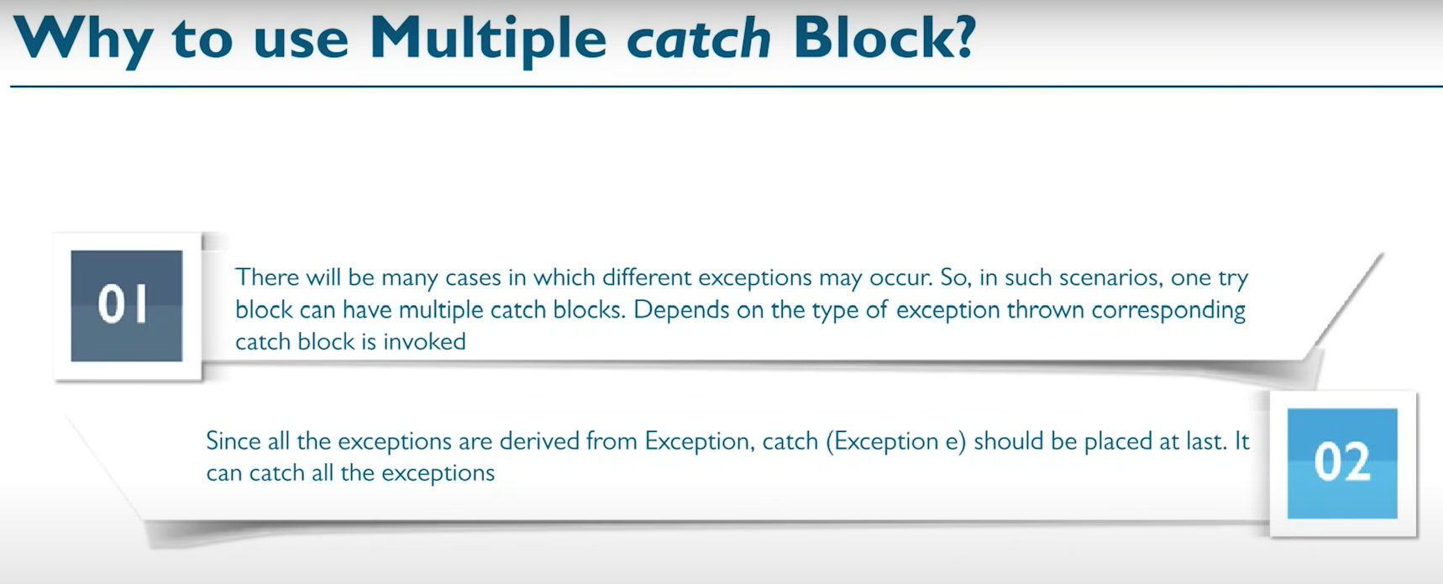

Error and Exception extends Throwable class.

Throwable class is extended by Object class.

Error is divided into :-

1. Thread Death

2. Virtual Machine error ( Out of memory)

3. IO Error

Exception is divided into:-

1. Runtime Exception (Unchecked Exception)

- Arithmetic

- ArrayIndexOutOfBound

- Null POinter

- It is your choose to handle or not

2. SQL Exception (Checked Exception)

- It is necessary to handle

3. IO Exception (Checked Exception)

- It is necessary to handle

Below is the hierarchy of exceptions. Exception is a Class, and there are child classes like ArithmeticException, ArrayIndexOutOfBoundsException – These are Unchceked exceptions.

Checked exception – These are mandatory to handle are SQLException

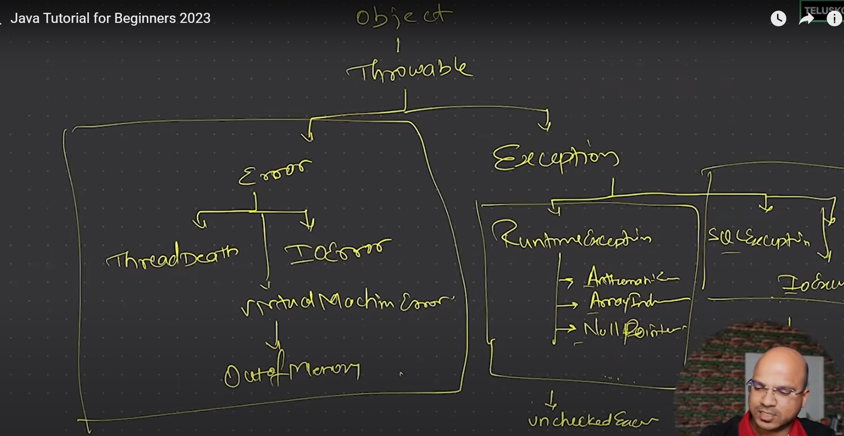

public class Demo {

public static void main(String[] args) {

// int i=2;

int i=0;

int j=0;

try

{

j=18/i;

if(j==0)

throw new ArithmeticException("I don't want to do print zero");

}

catch(ArithmeticException e)

{

j=18/i;

System.out.println("that is default output"+e);

// System.out.println("Cannot divide by zero");

}

catch(Exception e)

{

System.out.println("Something went wrong."+e);

}

System.out.println(j);

System.out.println("Bye");

}

}

Throws keyword is used when we want a method to “duck the exception” and say it just throws the exception be handled by the parent. E.g.

public void show() throws ClassNotFoundException which can be caught at the catch block as below:

catch(ClassNotFoundException e)

{

e.printStackTrace();

There is also a Finally block that gets executed irrespective of whether there is an exception or not. This is where generally the resources, databases. Etc are closed which should happen irrespective of there being an exception or not.

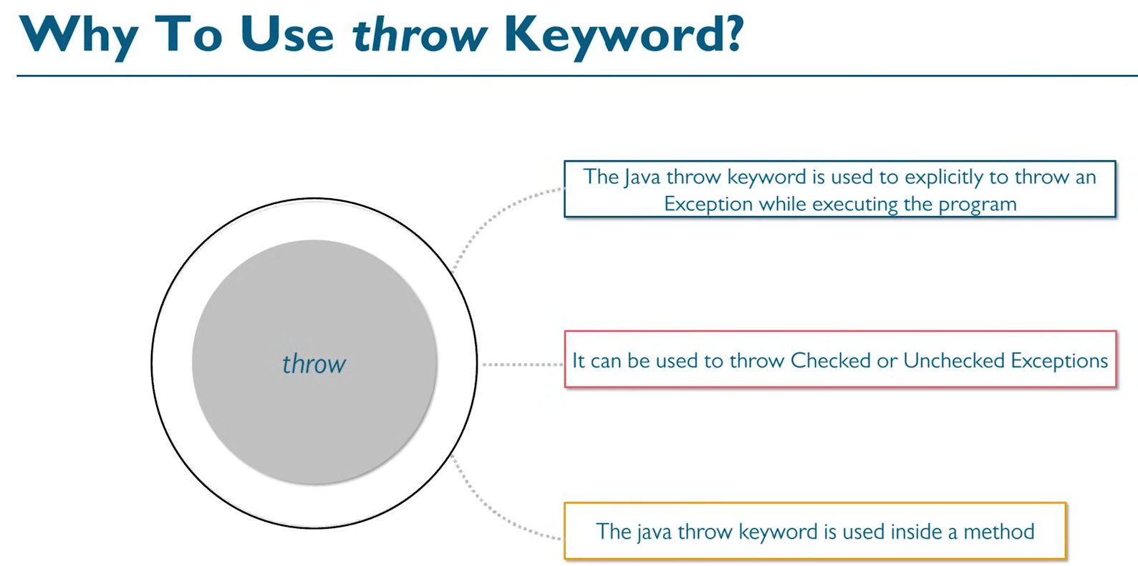

Basically if we know that a value can cause an exception, we can throw that before the next set of programs get executed. Also we can pass the message that needs to be thrown to the catch block so that the same message is displayed.

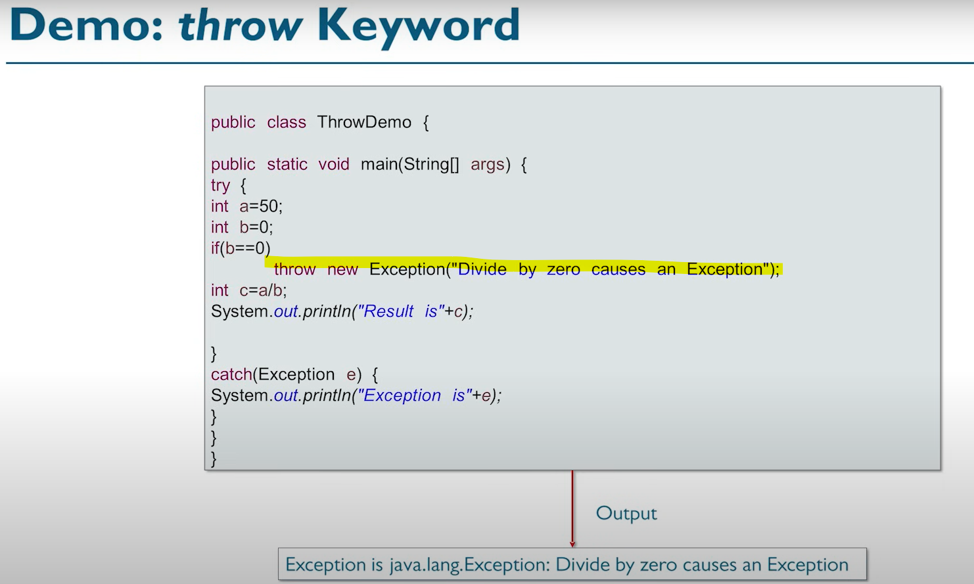

# File Handling

